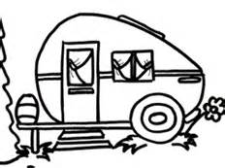
Camping Information for CRC
2017
There will be “dry” camping available at The Host. $75.00 per night for reservations received by the show closing date. If you have a room at the hotel, you don’t need to pay for camping, limit 1 RV per room paid for.
Sorry, the hotel would not budge on this price!
Please send the reservation form below and check made payable CRC to: Jodi LaBombard, 189 Miranda Lane, Roxboro, NC 27574-6602. If you have questions, please email Jodi; terry.jodi@gmail.com
If you prefer amenities, the campground below is across the highway from The Host.
Old Mill Stream Campground (directly across the highway from The Host), http://www.oldmillstreamcampground.com/ 717-299-2314
------------------------------------------------------------------------------------------------------
Name ___________________________________________________________
Email/phone number__________________________________________________
Check In Date ______________________________________________________
Departure Date ______________________________________________________
Travel Trailer / Motorhome _____________________________________________
Length _____________________________________________________________
Would you need a pump out? Yes or No?____________________________________

